(Approx. 1346 words)

Making Windows 10 Look and Act Like Windows 7
By Tom Burt, Vice-President, Sun City Summerlin Computer Club
Gigabyte Gazette, January 2020 issue
www.scscc.club
tomburt89134 (at) cox.net

Microsoft has ended support for Windows 7 on Tuesday, January 14th. After that date, there will be no further updates, bug fixes or security patches for Windows 7. The short-term consequences of the end of support are minimal: Windows 7 and installed applications will continue to work. Over time, however, as hackers discover new security flaws to exploit, Windows 7 will become less secure. So, it’s time to think about moving to Windows 10, which has a more secure core design and still has support.
Another concern for Windows 7 users is that it’s no longer available. If your current Windows 7 PC’s hardware finally gives up the ghost and can’t be repaired at a reasonable cost, your only option will be to buy a new Windows 10 PC via the retail market.
Coming from Windows 7, you may Initially find Windows 10’s user interface unappealing or difficult to navigate – especially the Settings interface. Our article this month will offer some ways to set up Windows 10 so that it looks and acts much like Windows 7. This can help with easing the transition to using the native Windows 10 user interface. For small businesses, this could afford a big saving on retraining staff accustomed to using Windows 7. We’ll also talk about some ways to get applications written for Windows 7 to run on Windows 10. This can be critical if the support for that application has gone away – a not uncommon occurrence with “free” programs downloaded over the years.

Helpful Articles
Here are some links to helpful articles I found while researching for this month’s article. I’ll be highlighting a few of the items these articles offered.
https://www.howtogeek.com/277448/how-to-make-windows-10-look-and-act-more-like-windows-7/
https://www.theguardian.com/technology/askjack/2019/jun/06/how-can-i-make-windows-10-look-more-like-windows-7
https://www.windowscentral.com/top-10-ways-make-windows-10-more-windows-7
https://www.digitaltrends.com/computing/how-to-make-windows-10-look-like-windows-7/

Classic Shell
One of the biggest differences between Windows 7 and Windows 10 is the Windows Start menu. Classic Shell is a free program that you can download and install to give you a variety of Start Menu styles, including that of Windows 7. You can find the download link at
http://www.classicshell.net/
The original author has placed the program in the public domain on GitHub.com, but you can still download his final version from the above site.
Classic Shell was originally built when Windows 8 was released; Windows 8 had NO Start Menu. It is compatible with Windows 8, 8.1 and 10. The articles above also offer a link where you can get an image file of the Windows 7 Start orb to be used with Classic Shell.

File Explorer
The Windows 10 File Explorer features the tabbed “ribbon” interface, which differs from Windows 7’s Windows Explorer, which featured a “menus and toolbar” interface. I didn’t find File Explorer that different and like the way it presents the user interface in the ribbon. But, for a closer recreation of Windows Explorer, the “Classic Shell” setup includes “Classic Explorer”, which allows you to get a highly customized File Explorer, including making it look and act like the Windows Explorer.

Task Bar
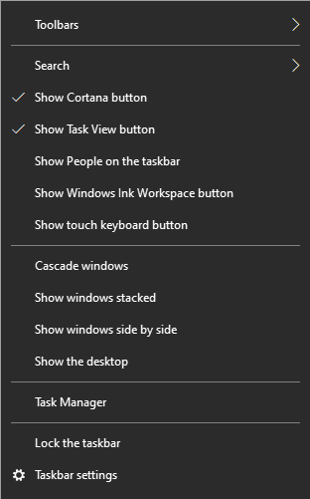
The Windows 10 Task Bar includes the Search box, the “Talk to Cortana” icon and the “Task View” icon. These are not present in Windows 7. To remove them, right-click on an open spot on the Task Bar to display a pop-up menu.

Uncheck the “Show Cortana button” and “Show Task View button” to remove those from the Task Bar.

If you hover over the Search item, a submenu slides out with toggle options to “Show search box”, “Show a search icon” or completely Hide the search.

You can also click “Taskbar Settings” to go to an extensive page of other Task Bar settings.

Title Bar Colors
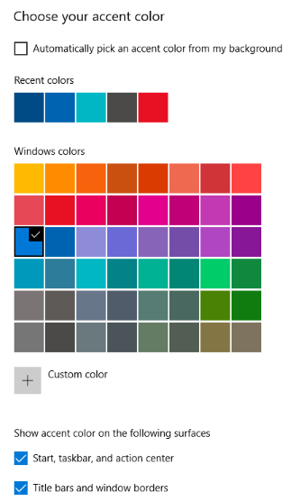
In Windows 10’s default color scheme, window title bars are colored white, making it difficult to see which Window has the focus to the mouse and keyboard. To add some color to title bars and other UI elements, you can go to Start > Settings > Personalization > Colors.

This will display a page of color settings. This screenshot shows the key parts for changing the color of various window and screen elements.

Uncheck (if checked) the “Automatically pick an accent color from my background” checkbox.

Select a pleasing accent color from the palette or click the + for a custom color. Check or uncheck the boxes for where the accent color should be used.

This tip can be handy even if you don’t use any of the others.

Program Compatibility
A separate concern from making Windows 10 look like Windows 7 is getting older programs that ran on your Windows 7 system to run on Windows 10. This can be a challenge for programs whose authors are no longer in business. Windows 10 provides options to run a program in “compatibility” mode and/or Administrator mode.
The best way to do this is to start by creating a desktop shortcut to the program. In File Explorer, browse to the program’s .exe file, right-click and, in the popup menu that appears, hover over “Send to” and then, in the secondary menu that appears, click “Desktop (create shortcut)”. See the following screenshot. Rename the desktop shortcut to something meaningful to you.
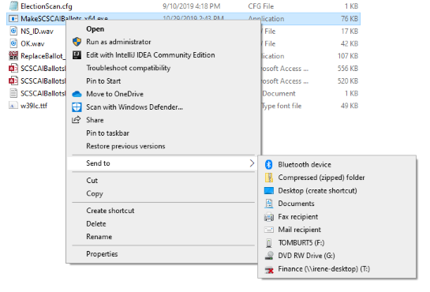

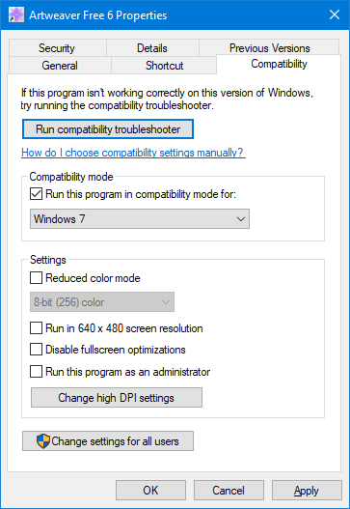
Next, right-click the shortcut and choose Properties from the popup menu. In the Properties dialog, click the Compatibility tab. Check the box for “Run this program in compatibility mode for:”
In the dropdown, choose “Windows7”.
You can also click the Shortcut tab and then click the Advanced button. A small dialog will display with a checkbox for “Run as administrator”. Try checking this box if the program still doesn’t run properly with Windows 7 compatibility selected.

When done with setting Properties, click OK. Then double click the shortcut to run the program. Hopefully, it will launch and run normally.
Some Windows 7 utility programs, especially those with accompanying drivers, may not run, even with compatibility mode.

Creating a Windows 7 Virtual Machine
If a program still fails to run on Windows 10 after you’ve tried Windows 7 compatibility and Run as administrator, you may want to try setting up a Windows 7 virtual machine. This requires a fair bit of technical skill, so I recommend visiting the SCSCC Tuesday Repair Lab team for help. Also, check out my “Virtual Machine Primer” seminar handout at https://www.scscc.club/smnr/Virtual_Machine_Primer.pdf
The most universal virtual machine utility is the free Oracle Virtual Box, which runs on Windows 10 Home or Pro, macOS and Linux. You can download Virtual Box at https://www.virtualbox.org/
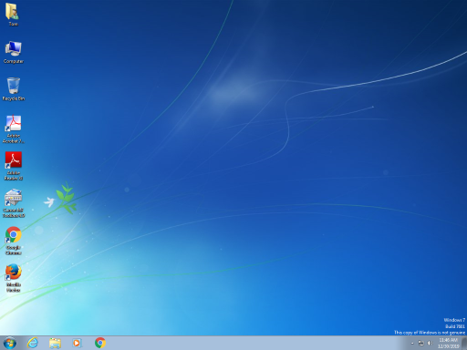
A virtual machine is a software/hardware emulation of a PC (the Guest) that runs as an application on a real PC (the Host). The Guest operating system and its applications run in the virtual machine and are unaware that they are running in a virtual environment. The virtual machine can be “booted” when needed and “shut down” when not needed. The virtual machine has a virtual hard drive, which is a single large file on the Host PC.
The general approach is to capture a snapshot of your Windows 7 PC’s C: drive and system partitions and use that snapshot to create the virtual hard drive file.

Windows 7 Running in a Virtual Box Virtual Machine on Windows 10
That virtual hard drive file is attached as the boot drive of a virtual machine configured to emulate a Windows 7 PC. Once this is done, you can “boot” the virtual machine and it will virtually start Windows 7 from the attached virtual C: drive. Your virtual machine will then be running your former Windows 7 PC and its applications.
The easiest way to make a snapshot of your Windows 7 PC’s C: drive and system partitions is to create a backup image using Macrium Reflect or Acronis True Image. That image can then be restored to the empty virtual C: drive of the Windows 7 virtual machine. Once the restore is done, the virtual machine will be able to boot up and the same Windows 7 and applications that you had on the original PC.

